15.80: a) The tension is the difference between the diver’s weight and the buoyant force,

b) The increase in tension will be the weight of the cable between the diver and the point at x, minus the buoyant force. This increase in tension is then

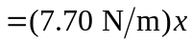
The tension as a function of x is then 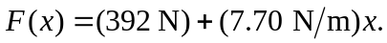 c) Denote the tension as 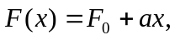 where 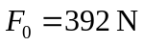 and 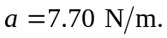Then, the speed of transverse waves as a function of x is 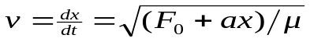 and the time t needed for a wave to reach the surface is found from

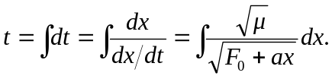

Let the length of the cable be L, so

